DD16n Nano D16US FrSky protocol diversity s bUS RX

SKU: 9171001374-0

Barcode: 188283

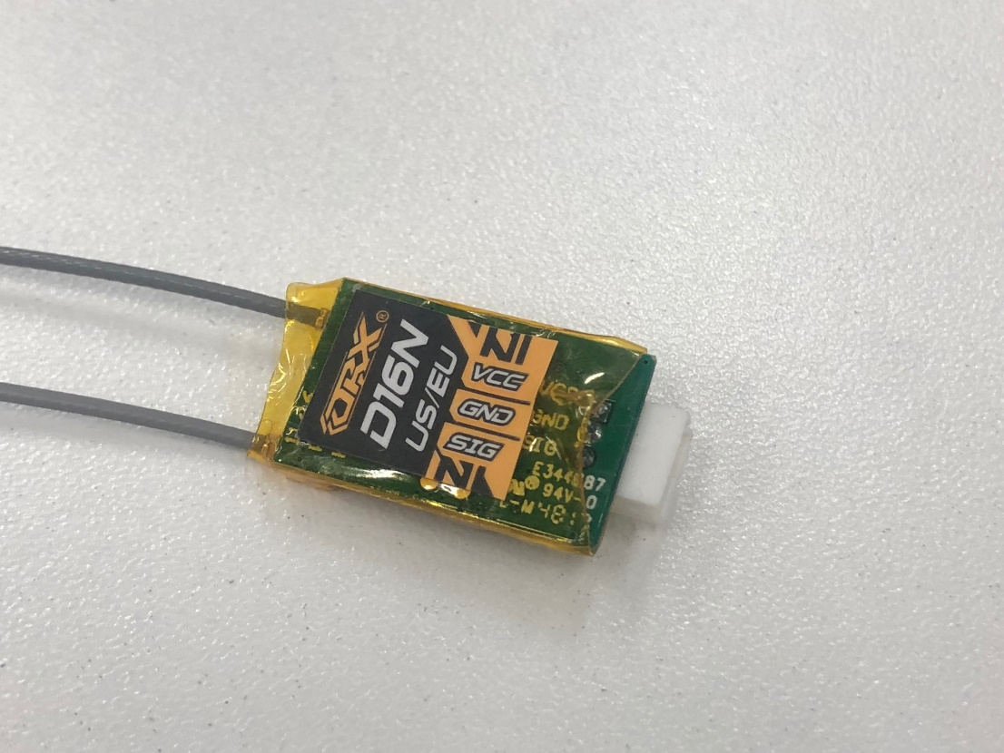

# Main features: - D16US/EU FrSky protocol (Auto detect) - 16 channels - 3.5v … 9.8v working voltage - Extra small size: 22x12.5x5mm - Ultra light – 1.5g without wires - Robust Autobind feature - Fail Safe - 5V-7.5V DC power - Output protocol: s.Bus, Please note: iBus, cPPM are also available. In order to change the output mode to following protocols please see the “How to change output mode” section

This receiver was designed keeping FPV racers in mind. It has small size and weight in the market, flat bottom surface which makes it easy to mount in the quad. It features TRUE DIVERSITY technology. It is especially important for FPV racing flights because the flight conditions are often far from ideal – low altitude, lots of obstacles and heavy impact of powerful video transmitter and motors working nearby. It is the situations where you need more robust reception. It is also very useful in aircrafts with carbon fiber frames where antenna can be in shadow of the airframe. We tested these receivers in real flight tests many times and achieved up to 750 meters line of site performance. Please note that your range depends on the conditions in your place – interference, WiFi presence, obstacles and even air humidity.

Instructions:  
**1. How to bind:**  
- Turn radio OFF  
- Turn receiver ON – provide power   
- After 8 seconds the blue LED will start rapidly blinking indicating that the receiver entered binding mode.   
- Bind to the transmitter according to the transmitter manual.

**2. How to change output mode:**- Remove heat shrinkfrom the receiver. On the bottom part there are several test points.   
- Short TP5 to the ground  
- Power the receiver ON.   
The protocol will be changed and LED blinks will indicate an active output protocol   
1 blink - iBus  
2 blinks - s.Bus normal  
3 blinks - s.Bus inverted  
4 blinks - cPPM

This receiver has been tested and fully compatible with following equipment:  
- Taranis X9D  
- Taranis X9D Plus  
- Horus X12S  
  
The receiver was tested with:  
- F1, F3, F4 Flight controls (Baseflight, Cleanflight, Betaflight, Raceflight):  
- KK2  
- MultiWii  
- APM(2.0 and up)  
Flybarless controls:  
- V-Bar (and compatible)  
- iKON  
**Specifications:**  
Frequency: 2.4Ghz   
Modulation: GFSK  
Sensitivity: up to -98dBm  
Protocol: FrSky D16 US/FCC Compatible.   
Output protocol – - s.Bus, iBus, cPPM  
Telemetry - RSSI  
Additional feature – Autobind after 8 seconds power on if the previously bound transmitter signal is not present  
Size: 22x12.5x5mm  
Wire Length: 210mm  
Antennae Length: 145mm  
Weight: 1.5g